UNIT-I INTRODUCTION

* **Computer architecture**
* Refers to those attributes of a system visible to a programmer or, put another way, those attributes that have a direct impact on the logical execution of a program.
* Examples of architectural attributes include the instruction set, the number of bits used to represent

various data types (e.g., numbers, characters), I/O mechanisms, and techniques for addressing memory.

* **Computer organization**
* Refers to the operational units and their interconnections that realize the architectural specifications.
* Organizational attributes include those hardware details transparent to the programmer, such as control signals; interfaces between the computer and peripherals; and the memory technology used.
* For example, it is an architectural design issue whether a computer will have a multiply instruction. It is an organizational issue whether that instruction will be implemented by a special multiply unit or by a mechanism that makes repeated use of the add unit of the system.
* **The components from which computers are built, i.e., computer organization.**
* **In contrast, computer architecture is the science of integrating those components to achieve a level of functionality and performance.**

Basic Terminology

* 1. **Input** Whatever is put into a computer system.
  2. **Data** Refers to the symbols that represent facts, objects, or ideas.
  3. **Information** The results of the computer storing data as bits and bytes; the words, numbers, sounds, and graphics.
  4. **Output** Consists of the processing results produced by a computer.
  5. **Processing**Manipulation of the data in many ways.
  6. **Memory** Area of the computer that temporarily holds data waiting to be processed, stored, or output.
  7. **Storage** Area of the computer that holds data on a permanent basis when it is not immediately needed for processing.

1. Basic Terminology
2. **Assembly language program (ALP)** –Programs are written using mnemonics
3. **Mnemonic** –Instruction will be in the form of English like form
4. **Assembler** –is a software which converts ALP to MLL (Machine Level Language)
5. **HLL (High Level Language) –**Programs are written using English like statements
6. **Compiler -**Convert HLL to MLL, does this job by reading source program at once
7. Basic Terminology
8. **Interpreter** –Converts HLL to MLL, does this job statement by statement

**Operating system –**Collection of routines responsible for controlling and coordinating all the activities in a computer system

**Computers have two kinds of components:**

1. **Hardware,** consisting of its physical devices (CPU, memory, bus, storage devices ...)
2. **Software,** consisting of the programs it has (OS, applications, utilities, ...)

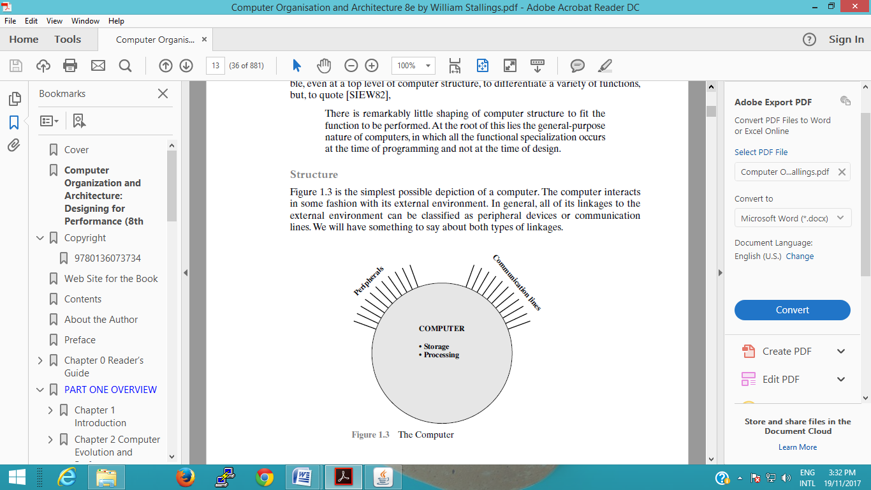

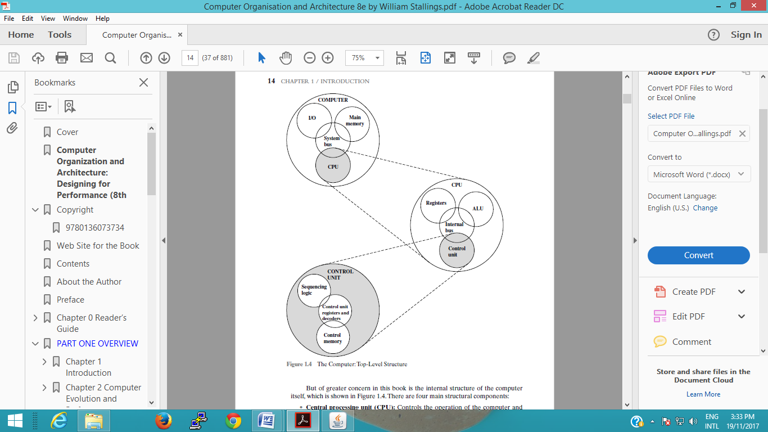

1. **FUNCTIONAL UNITS OF COMPUTER**

* Input Unit
* Output Unit
* Central processing Unit (ALU and Control Units)
* Memory
* Bus Structure

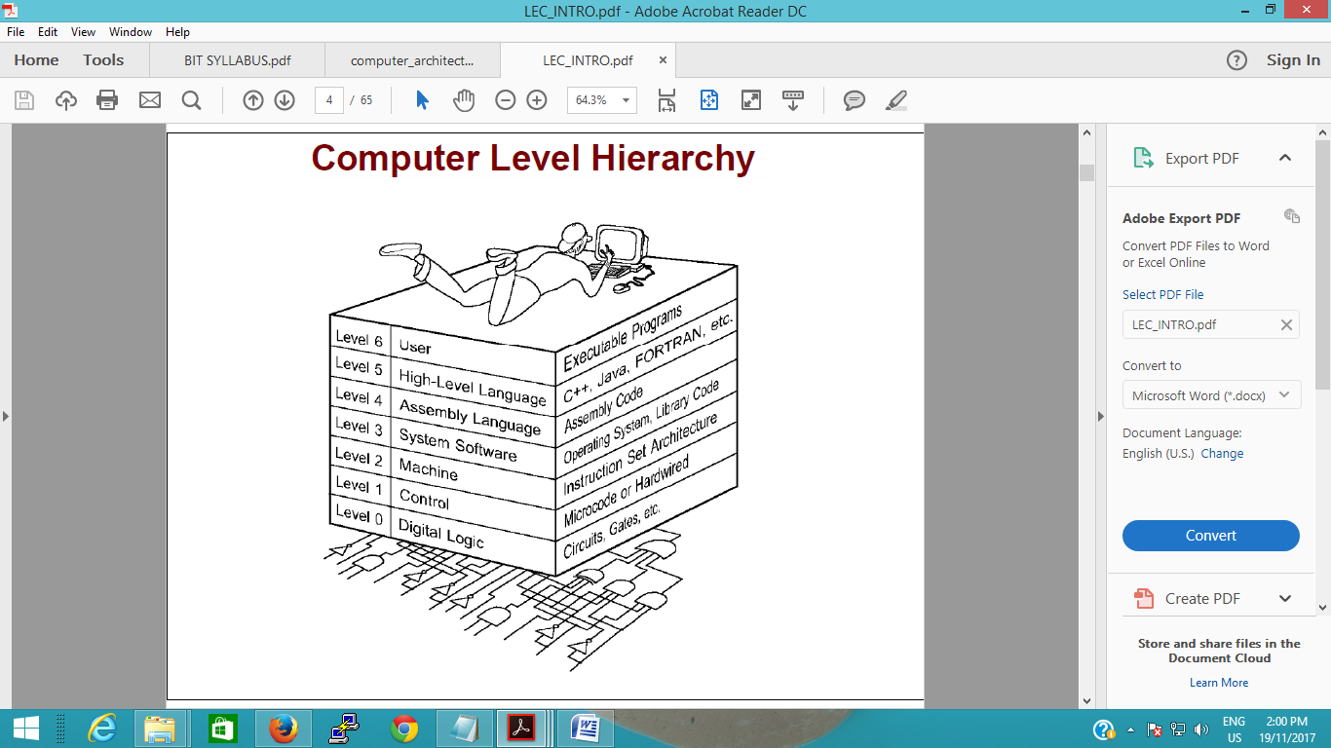

**Program Execution**

Translation: The entire high-level program is translated into an equivalent machine language program. Then the machine language

Program is executed.

Interpretation**:** Another program reads the high level program instructions one-by-one and executes a equivalent series of

Machine language instructions**.**

**Program translation** uses a collection of tools to perform the translation

_ Compiler: Translates high level language programs into a lower level language often called object code.

**_** Assembler: Translates assembly language instructions into object code.

_ Linker: Combines collections of object code into a single executable machine language program.

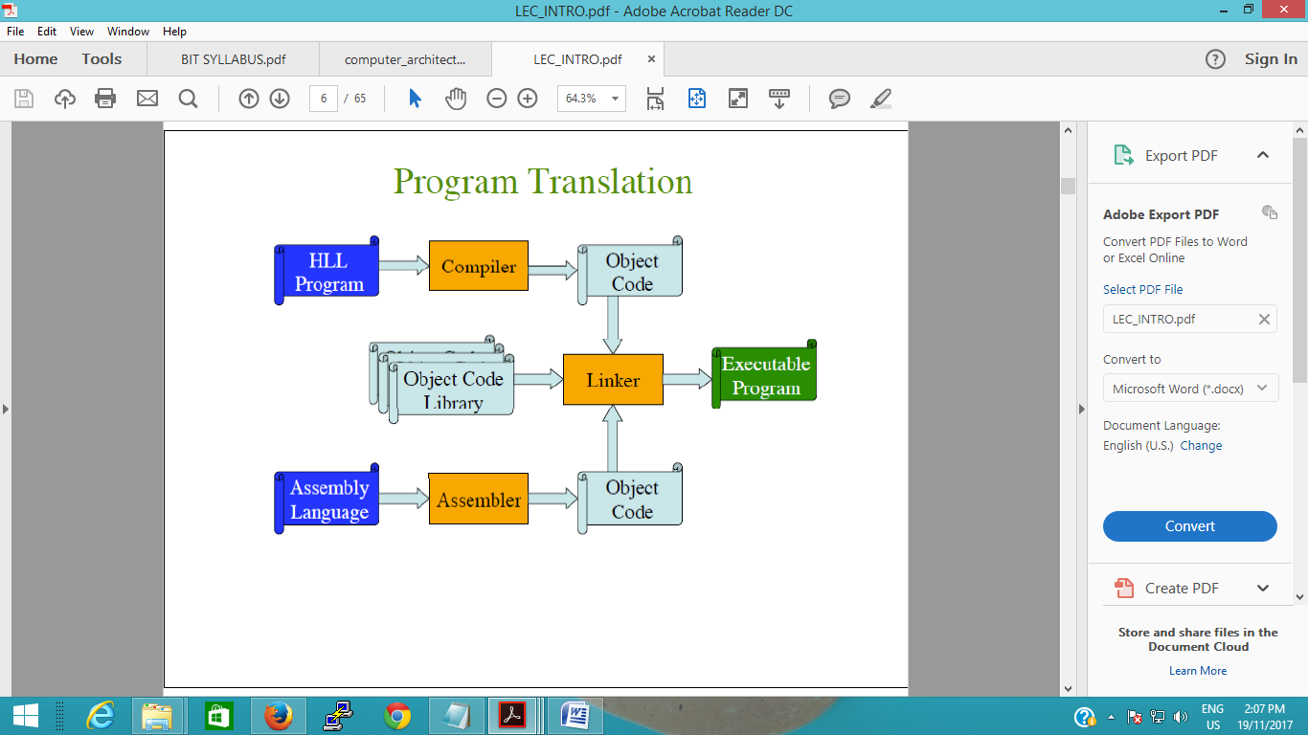

**Structure:** The way in which the components are interrelated

**Function:** The operation of each individual component as part of the structure

**There are four main functions of a computer:**

* Data processing
* Data storage
* Data movement
* Control

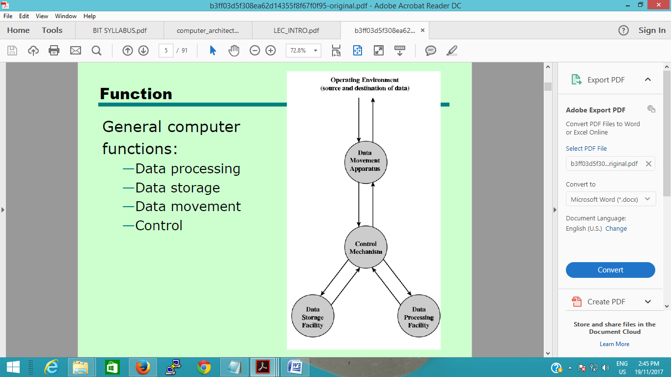

**MAIN STRUCTURAL BLOCKS/PARTS:**

**Central Processing Unit (CPU):** Controls the operation of the computer and performs its data processing functions. Often simply referred to as processor.

**Main Memory:** Stores data.

**I/O:** Moves data between the computer and its external environment.

**System Interconnection:** e.g. BUSfor communication among CPU, main memory, and I/O.The major structural components of a CPU are:

**Control Unit (CU):** Controls the operation of the CPU and hence the computer.

**Arithmetic and Logic Unit (ALU):** Performs computer’s data processing functions.

**Register:** Provides storage internal to the CPU.

**CPU Interconnection:** communication among the control unit, ALU, and register.

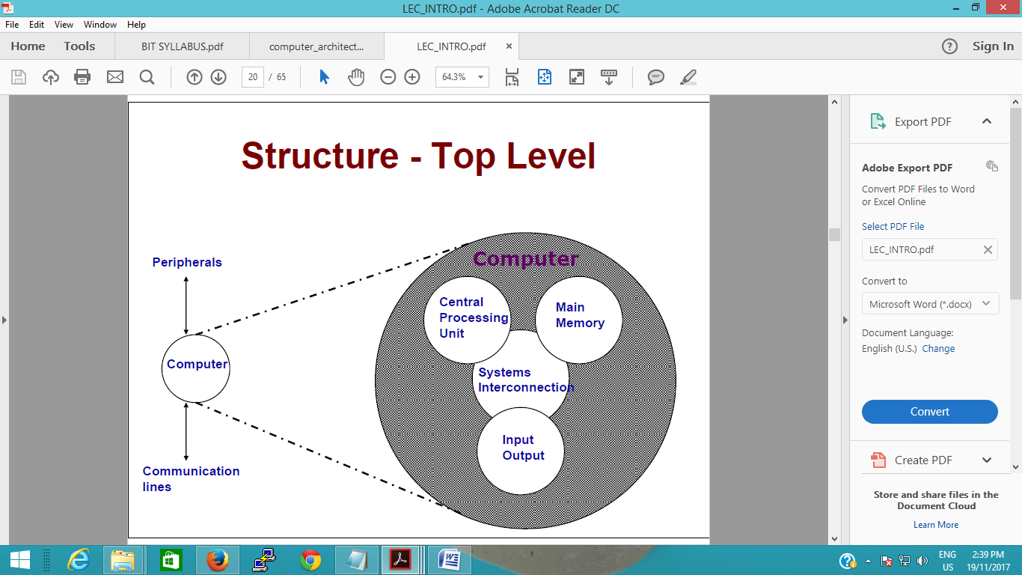

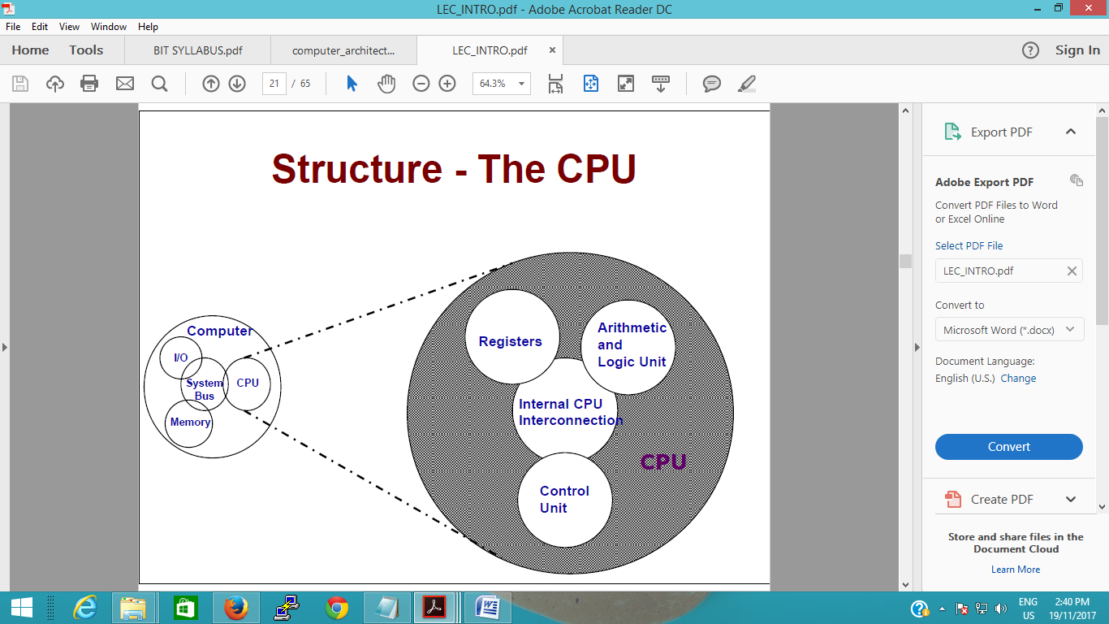

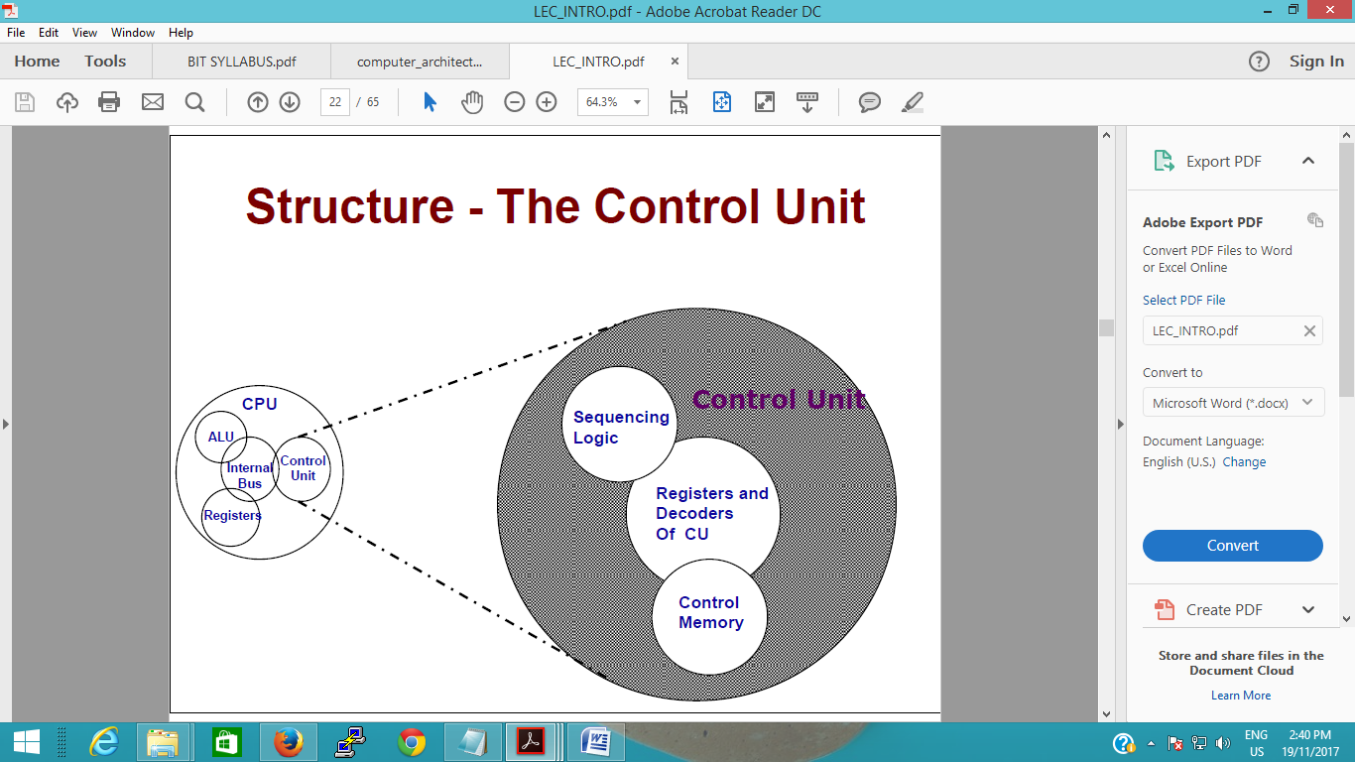

**Stored Program Concept**

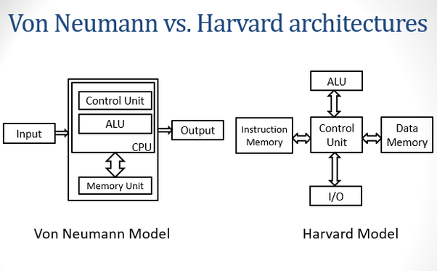

four general purpose registers

**There** are four **general purpose registers** which are AX, BX, CX and DX.

•

AX, which is named the accumulator. It is used for all input/output operations and some [arithmetic operations](https://www.sciencedirect.com/topics/computer-science/arithmetic-operation). For example, multiply, divide and translate instructions assume the use of AX.

•

BX, which is named the base register. It can be used as an address register.

•

CX, which is the count register. It is used by instructions which require to count. Typically it is used for controlling the number of times a loop is repeated and in bit shift operations.

•

DX, which is the data register. It is used for some input/output and also when multiplying and dividing.